**The Black Death aka the Bubonic Plague**

**The Corona Virus aka COVID-19**

There was a philosopher, George Santayana, who said, “Those who cannot remember the past are condemned to repeat it”. Now this quote has gone all to be repeated and adapted in all sort of ways. However, many people (including myself) still believe its warning holds true. All throughout history we see patterns that we can link to events that happened in earlier times. For example, Hitler should have learned from Napoleon’s failed invasion of Russia or that the some of the same mistakes made by financial institutions in the Great Depression in 1929 were made again in the Recession of 2008.

**Your mission, if you choose to accept it:**

*If you can tell me the movie reference from above you’ll win brownie points.* I would like you all to find the patterns and similarities between the Corona virus and the Black Plague. Go through and look at the sites and videos I have included and record your thoughts as you go. ***Make sure you allow Flash players in your web browser to see some of these maps.

The final questions that I want you to think about is this:

**Is the Corona virus (COVID-19) this era’s Black (Bubonic) Plague?**

1. The first thing that you will need to do is see how far the black death spread during this time period. [Click here,](http://wadsworth.cengage.com/history_d/templates/student_resources/0534600069_spielvogel/InteractiveMaps/swfs/map11_1.html) that will take you to a map of Europe. Go through and click on December of 1347, December of 1348, December of 1349, and December of 1350.
   1. How far the plague was able to spread every year during this three year period. Why do you believe that the plague spread as quickly as it did in such a short time?
   2. At the end of the interactive map there were unaffected areas. Why do you believe that these areas were not affected by the black plague?
2. [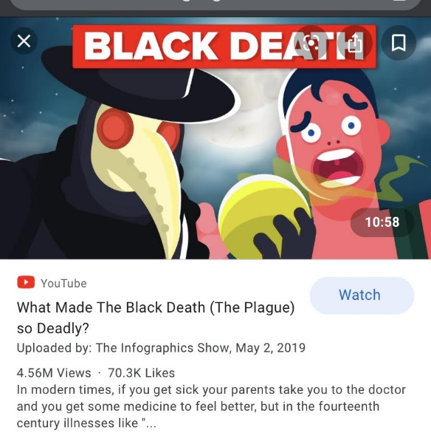](https://www.youtube.com/watch?v=m5q-PIN3KSE)Watch this video over the Black Plague. You click on the picture or click on the link <https://www.youtube.com/watch?v=m5q-PIN3KSE>. Be thinking about the questions below:
   1. What impact did trade have on the black plague?
   2. What were some of the symptoms that went along with the black death?
   3. How long did someone live after they got the black death?
   4. Would the plague have made it to Europe without the help of fleas and rats?
   5. What was thought to be the best treatment for the black plague?
   6. Of the treatments listed, which do you believe is the most helpful? Ridiculous?
3. [A picture containing shirt

   Description automatically generated](https://www.youtube.com/watch?v=0bnYqM1AdXY)Now watch this video about Corona Virus. Again, you can either click on the picture or click the link <https://www.youtube.com/watch?v=0bnYqM1AdXY> .
   1. What is a Corona virus?
   2. What are the symptoms of COVID-19?
   3. How do you think the COVID-19 spread from China?
4. View this timeline of the Coronavirus <https://www.healthmap.org/covid-19/>
   1. When did the Corona outbreak begin?
   2. How long did it take to spread to a new region of the world? Months? Days?
   3. Do you think that there will be areas of the world not affected (Antarctica and the Arctic don’t count)?
5. Game time! Time to see how easy it is for a pandemic to spread across the globe. Click the picture or <https://www.crazymonkeygames.com/Pandemic-2.html>. **There is a tutorial page for you to look at if you get lost in the game.** 
   1. How long did it take you to spread your disease to another country the first time??

[](https://www.crazymonkeygames.com/Pandemic-2.html)

* + 1. What is the shortest time you won in?
  1. What were some of the world’s responses to your disease?

**Final Question:**

**Is the Corona virus (COVID-19) this era’s Black (Bubonic) Plague? Support your answer with two details that you learned today.**